**MANUAL**

**FOR**

**LABORATORY PRACTICAL AND DESIGN STUDIO I (CVE 325, 2UNITS)**

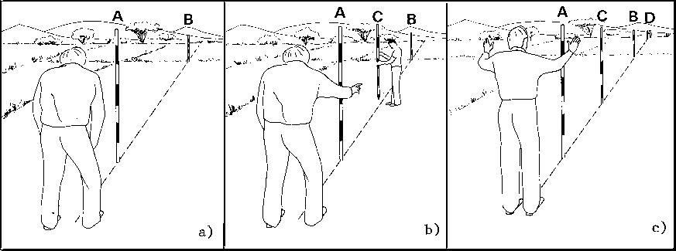

**DEPARTMENT OF CIVIL ENGINEERING**

**FACULTY OF ENGINEERING**

**FEDERAL UNIVERSITY OYE-EKITI**

**PREPARING LABORATORY REPORTS**

The following guideline is used to prepare laboratory reports.

1. **Title:** This section contains the title of the test, the nature of the test and the specification number used.
2. **Scope of the test:** A brief statement of the purpose and significance of the test should be indicated.
3. **Apparatus:** Equipment used should be briefly described.
4. **Materials:** The materials used or tested should be described.
5. **Theory:** This section summarizes the test/experiment or it gives us an overview of what the test is all about.
6. **Definitions and Process Terminology:** This section contains terminology and definition of specific words and test related terms.
7. **Procedure:** Clearly and concisely list the procedure in the order the test is carried out.
8. **Raw Data:** This section contains the raw data gotten from the test. All laboratory data shall be submitted in tabular form.
9. **Calculations and Results:** Observations relating to the behavior of the

materials should be included. All equations or formulas used should be clearly indicated. Calculations should be properly checked. The results of the test should be summarized in tabular or graphical form.

1. **Figures and Diagrams:** This section contains clear and concise diagrams and/or figures in accordance with the laboratory requirement. Figures including the equipment front and side views, parts and panels can be displayed in this section.
2. **Discussion:** There should be included a brief discussion in which attention is drawn to the silent facts shown by the tables and diagrams. The test results should be compared with the standard values.
3. **Conclusion:** Include modification procedures, calibration procedures and any additional information that will be helpful.
4. **References (if applicable):** Include references to any manuals, documents or textbooks used in compiling the reports.

**INTRODUCTION TO DESIGN STUDIO**

Digital design is the method by which graphic designs and models are created using software applications in computers, tablets, digital drawing tools for print, web, television, electronic devices and other media of innumerable nature and varieties. Digital designs can include contents such as multimedia presentations, social media collateral, email and web ads, digital billboards and signage, pitch decks, 3D modeling and 2D animations. In Civil Engineering, digital design helps in planning, designing, documentation, modification, costing, modeling, optimization and implementation of designs etc. Examples of some of these software applications include Autocad, Autodesk, Archicad, Orion, Revit, Adobe Creative Suite etc.

**What is CAD?**

CAD stands for Computer Aided Design. CAD involves the use of computers (or workstations) to aid in the creation, modification, analysis and/or optimization of a design.

**What is CAM?**

CAM stands for Computer Aided Manufacturing. CAM is an application technology that uses computer software and machinery to facilitate and automate manufacturing processes. It involves the use of software to control machine tools used in manufacturing processes and also enables faster, accurate and more precise production of components. It refers to the use of a computer to assist in all operations of a manufacturing plant, including planning, management, transportation and storage.

**What is CAE?**

CAE stands for Computer Aided Engineering. CAE is the broad usage of computer software to aid in engineering analysis tasks. It includes Finite Element Analysis (FEA), Computational Fluid Dynamics (CFD), Multi-body Dynamics (MBD) etc.

**Types of CAD Software:**

* 2D Software
* 3D Software
* 3D Wireframe and Surface Modeling Software
* Solid Modeling Software

**Uses of CAD:**

* Modeling
* Drawing specification
* Designing
* Cost Analysis
* Documentation

**Components of a typical CAD Software:**

* Drafting screen
* Text input and measuring tools
* Drafting tools
* Layer list
* Block list

**Benefits of CAD:**

* Increase in productivity of the designer
* Improves the quality of the design
* Better communications
* Creating documentation of the design
* Creating database for manufacturing
* Saving design data and drawings
* Helps to minimize drafting errors during manufacturing
* Efficiency in the quality of design
* Saves time and money
* Improved accuracy in rendering designs and drawings

**TERMINOLOGIES USED IN DESIGN STUDIO**

**ARIA (Accessible Rich Internet Applications):** Semantics designed to properly convey appropriate information to persons with disabilities.

**Alignment:** Is the adjustment of arrangement or position in lines of a text or an image; left, right, centered etc.

**Alpha Channel:** Is the process of incorporating an image with a background to create the appearance of partial transparency. Alpha Channels are used to create masks that allow you to confine or protect parts of an image you want to apply colour, opacity, also, to make other changes.

**Analog Proof (Prepress Proof):** A Proof that uses inkjet, toner, dyes, overlays, photographic, film or other methods to give an idea of what the finished product should look like.

**Animated GIF:** A small animation based on continuous GIF images, giving the impression of movement or action.

**Animation:** Generating movement by displaying a series of images using frames.

**Asymmetrical:** This is when graphics and/or text are not identical on both sides of a central line.

**Baseline:** An imaginary line upon which letters sit and descenders extend below the baseline.

**Bevel:** A tool in design software for drawing angles or modifying the surface of work to a certain inclination.

**Bezier Curve:** A parametric curve that represents a vector path in computer graphics. They are frequently drawn using a pen tool and by placing anchor points which can be controlled to form shapes or lines.

**Bitmap:** A series of bits in a structure that represents a graphic image. The colour of each pixel is individually defined.

**Bleed:** When a graphic object extends through another in an unwanted manner. It is then trimmed so there is no chance for a white line on the edges.

**Border:** The decorative design or edge of a surface or line or area that forms its outer boundary.

**Canvas Size:** Allows you to change the complete size of the document without adjusting the components of the document.

**Clipping Path:** A tool that or shape used to cut out an image.

**Cloning Pixels:** A function that allows you to replicate pixels from one place to another.

**Color Palette:** A set of colours that make up the total range of colours used in graphic computers.

**Contrast:** The difference in colour found between the light and dark parts of an image.

**Crop:** A tool that removes portions of an image.

**Die Cut:** Is a die that cut shapes or holes in a wide range of material.

**Dodge:** This is when you lighten or reduce part of an image by shading.

**Double Page Spread:** A double page spread is a layout that extends across two pages.

**DPI (Dots Per Inch):** A term to describe the measure of sharpness within an image.

**Drop Shadow:** Is a visual effect added to an image to give the impression the image is raised above the image’s behind by replicating the shadow.

**Dummy:** This is a display of the final product.

**Duotone:** A method of printing an image using two colours, usually black and a spot colour.

**Element:** Any distinct part of a layout such as a logo, headline, images or borders.

**Embedding:** Process of transferring all the data of a font or image into the file itself.

**Emboss:** To give a three dimensional effect to a text or an image by using highlights and shadows on the sides of the illustration.

**Engraving:** To print designs by cutting the surface of a metal plate.

**EPS (Encapsulated Post Script):** This is a graphics file format used to transfer PostScript documents that contain an image, within another PostScript document.

**Etch:** To imprint a design onto the surface of a plate by using a chemical such as acid.

**Export:** To save a file in a format usable by other programs.

**Feathering:** A tool used in graphic design software that makes the edges of an image appear softer.

**Fill:** A tool used to fill selected parts of an image with a selected colour.

**Gatefold:** The type of fold in which the paper is folded inward to form four or more panels.  
**Gradient:** A function in graphic software that permits the user to fill an object or image with a smooth transition of colours.

**Grayscale:** Grayscale images consists of black, white, no colour and up to 256 shades of gray.

**Grid:** Is a two-dimensional format made up of a set of horizontal and vertical axis used to structure content.

**Hard Copy:** The permanent reproduction of the output of a computer or printer.

**Header:** The text which appears at the top of a printed page.

**Headline:** A large text illustrating the opening statement used in a layout.

**High-Resolution Image:** An image with an extreme level of sharpness/clarity.

**HLS:** A colour space that stands for hue, lightness and saturation.

**HSB:** A colour space that stands for hue, saturation and brightness.

**Kerning:** Modifying the horizontal space between letters.

**Keyframe:** Any frame in which a specific aspect of an item (its size, location, colour etc) is specifically defined.

**Layers:** The tools within graphic software that permits the user to gather, organize and re-edit their artwork.

**Leading:** Refers to the amount of added vertical spacing between lines of text.

**INTRODUCTION TO SURVEY EQUIPMENTS**

**Aim:** To study various survey equipment

Survey equipment are divided into four categories:

1. Equipment used for linear measurements
2. Chain or tape
3. Arrows
4. Pegs
5. Ranging Poles
6. Offset Rods
7. Plumb Bob
8. Optical Square
9. Line Ranger
10. Equipment used in angular measurements
11. Compass
12. Theodolite
13. Total Stations
14. Equipment used in vertical measurements
15. Leveling Staff
16. Dumpy Level
17. Equipment used for measurement of area
18. Planimeter

**1.** **Plumb bob:** A plumb-bob or a plummet is a weight, usually with a pointed tip on the bottom suspended from a string and used as a vertical reference line, or plumb-line. A plumb bob is used to check if objects are vertical. Plumb bobs may weigh as little as an ounce or as much as several pounds, depending upon the application. It consists of a piece of metal (called a bob) usually with a pointed tip, which is attached to a cord. While chaining along sloping ground, a plumb bob is required to transfer the points to the ground.

**How to Use a Plumb Bob**  
To use this tool, the string is fixed at the point to be plumbed. The weight, or bob, is then allowed to swing freely; when it stops, the cord or object is vertical.

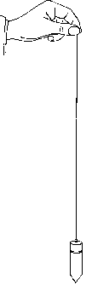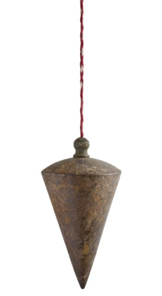

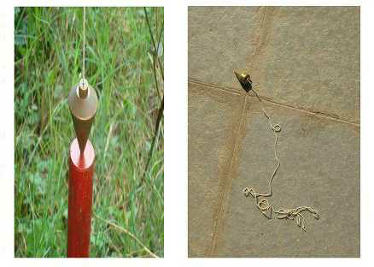

**2.** **Ranging pole:** A range pole, which may also be called a lining pole, is a pole painted with alternating stripes of different colors in consistent widths used often to site measurements. Regular range poles are commonly 8 feet (approximately 2.4 meters) long and 0.5 to 1 in. (about 1.25 to 2.5cm) in diameter.

Ranging poles are used to mark areas and to set out straight lines on the field. They are also used to mark points which must be seen from a distance, in which case a flag may be attached to improve the visibility. Ranging poles can also be home made from strong straight bamboo or tree branches. Ranging poles are usually painted with alternate red-white or black-white bands. If possible, wooden ranging poles are reinforced at the bottom end by metal points.

**Features:**

1. It can be either wood or metal

2. Its length ranges from 1. 8m, 2.4m to 3.0m

3. It is either circular or octagonal in shape

4. It is pointed with different colours of black, red and white

5. The reason for painting with different colours is to enable it to seen from a far.

6. It is used for marking spots or stations.

7. It can also be used for making straight lines.

8. It has a pointed end.

9. Its thickness ranges from 3 to 4cm.

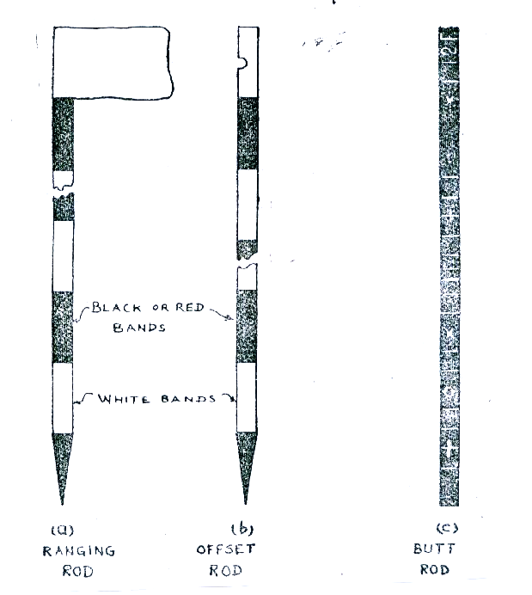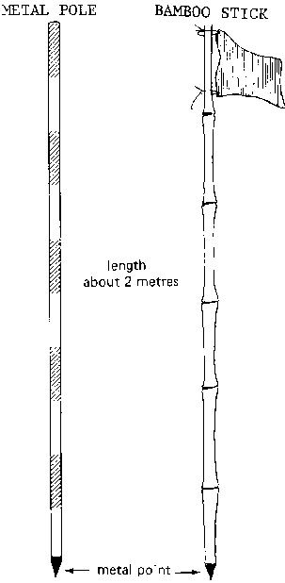

**3. Arrows:** Arrows are made of good quality hardened steel wire of 4 mm diameter. The arrows are made 400 mm in length, are pointed at one end and the other end is bent into a loop or circle.

**Features:**

1. It is made of steel wires.

2. It is about 30cm long.

3. One end of the pin is curved into a ring.

4. During usage, a red cloth is tied to the ring end.

5. The red cloth enables the pin to be seen from afar.

6. It is used for marking off chain lengths as measured.

7. It can also be use for marking spots or stations.

8. It has a thin pointed end.

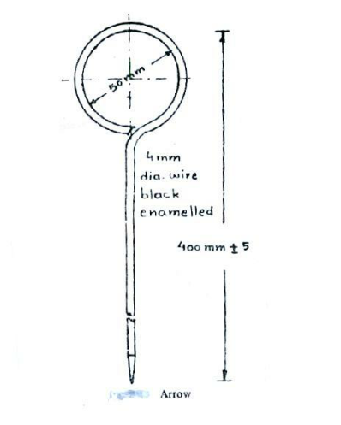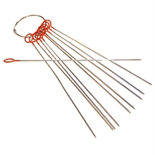

**4. Chain:** A chain is used to measure distance on the field. The chain is composed of 100 or 150 pieces of connected galvanized mild steel segments, 4mm in diameter and 20cm called links. The ends of each link are bent into a loop and connected together by means of three oval rings. The ends of the chain are provided with handles for dragging the chain on the ground, each wire with a swivel joint so that the chain can be turned without twisting.

Usually, a chain has a total length of 20 meters, including one handle at each end. The length of the chain is measured from the outside of one handle to the outside of another handle.

**Types of chains:**

The following are the various types of chains used in surveying:

1. Metric chain
2. Gunter`s chain or surveyors chain
3. Engineers chain
4. Revenue chain
5. Steel band or Band chain

**Features of a Metric chain:**

1. Metric chains are made in lengths 20m and 30m.

2. Tallies are fixed at every five-meter length and brass rings are provided at every meter length except where tallies are attached.

**Features of a Gunter’s chain:**

1. This is surveyor’s chain that was used before tapes were discovered.

2. It is made of steel wires which are dumb-bell in shape.

3. Each chain is joined together by links of three small rings.

4. A Gunter’s chain is about 66ft or 20. 13m in length.

5. Each chain is made of about 100 links and each link is about 19.8cm or 7.92 inches.

6. It is used in taking detailed measurement of the length and breadth of land.

7. The handle at each end is made of brass.

8. A link is the distance between two central rings.

9. It is majorly used in taking short or detailed measurement of length and breadth.

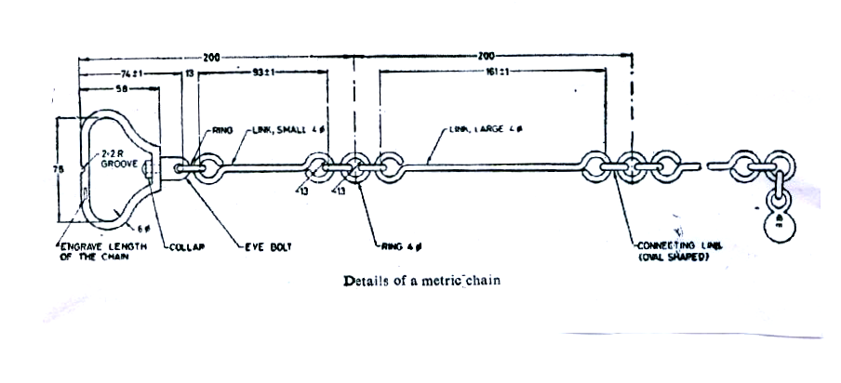

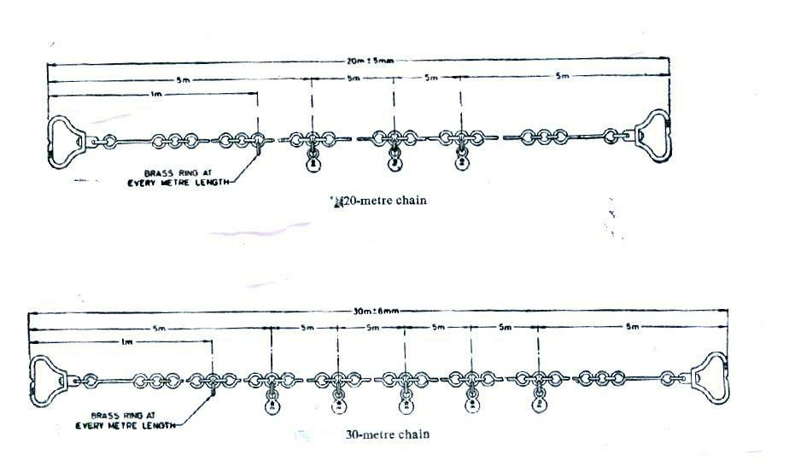

**5. Measuring tapes:** Measuring tapes are made of steel, coated linen, or synthetic material. They are available in lengths of 20, 30 and 50 m. Tapes are graduated in centimeters, decimeters and meters are usually indicated on the tape.

Among the different type of tapes, the metallic tapes are widely used in surveying. A metallic tape is made of varnished strip of waterproof line interwoven with small brass, copper or bronze wires. They are light in weight and flexible and are made to different lengths or sizes as 2m, 5m 10m, 20m, 30m, and 50m.

**Types of tapes:** The following are the various types of tapes

1. Cloth tape
2. Metallic tape
3. Steel tape
4. Invar tape

**Features:**

1. There are steel tapes and linen tapes.

2. It is marked on one side in metric units and on the other side in imperial units.

3. It is of varying lengths and types.

4. It is used for taking measurements of length, breadth and height.

5. The tape is normally wound in a small case from where it is unwound for use.

6. It is used to form 3-4-5 methods of measurement.

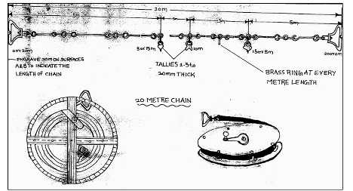

**6. Pegs:** Pegs are used when certain points on the field require more permanent marking. Pegs are generally made of wood; sometimes pieces of tree-branches, properly sharpened, are good enough. The size of the pegs depends on the type of survey work they are used for and the type of soil they have to be driven in. The pegs should be driven vertically into the soil and the top should be clearly visible.

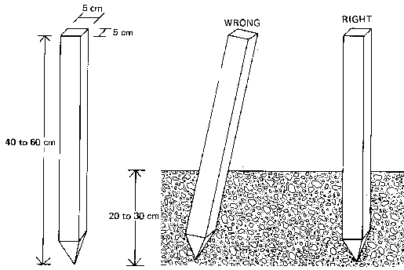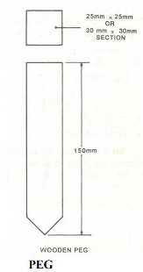

**7. Cross staff:**

This is the simplest instrument used for setting out a right angle. The common forms of cross staff are:

* Open cross staff
* French cross staff

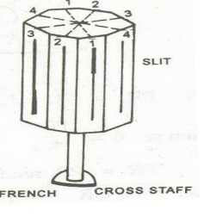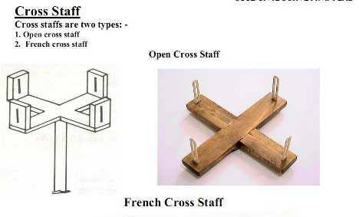

**8. Offset rod:**

The offset rod is used for measuring the off set of short lengths. It is similar to a ranging rod and is usually of 3m lengths.

**Features:**

1. It is a graduated rod.

2. It is about 3m long.

3. A hook may be attached to the top, which helps in the pulling of chains through hedges.

4. It is used for taking short off-set measurements.

5. There is a telescopic link which is 0.3m (30cm) in length.

**9. Theodolite:**

A theodolite is a precision instrument for measuring angles in the horizontal and vertical planes. A modern theodolite consists of a movable telescope mounted within two perpendicular axes—the horizontal or trunnion axis, and the vertical axis. When the telescope is pointed at a desired object, the angle of each of these axes can be measured with great precision, typically on the scale of arcseconds.

**Types of theodolite**

1. Transit and non-transit theodolite
2. Vernier and Micrometer Theodolite
3. Electronic Theodolite
4. Optical Theodolite

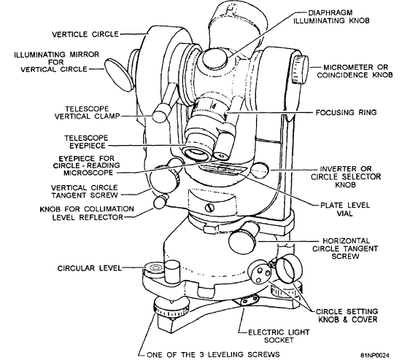

**10. Dumpy Level:**

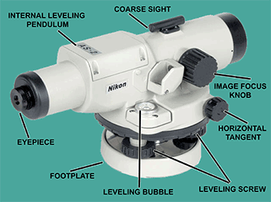A **dumpy level** is an instrument used to measure, transfer or set horizontal lines. It is an instrument that is often used in surveying buildings. A dumpy level is used to establish relative height, distance and bearings from different parts of a site. Using this instrument requires a certain amount of skill.

**Uses of Dumpy Level**

* Determining the height of a particular point.
* Determining differences in height between points.
* Drawing contours on a land.
* Providing data to calculate volumes for earthworks.
* Setting out level surfaces for construction.
* Setting out inclined surfaces for construction.

**Setting up the dumpy level**

* Choose a position for the dumpy with a good sightline to the datum and also to as much of the ground to be surveyed as possible. Further up the slope is more useful than too low down on the slope. Use the full height of the staff where possible.
* Set up the tripod – it has adjustable feet to allow it to be upright on uneven ground. Ensure the tripod is secure, its feet pressed into the ground if possible. Do not disturb the tripod until it is time to move it again.
* Attach the dumpy to the tripod.
* Level the dumpy using the spirit level – the bubble must be centered in its circle. Turn 2 of the adjustable screws towards or away from each other until the bubble is near the centre. Turn the dumpy 90° towards the untouched screw and adjust this till the bubble is centered.

**STUDY OF THEODOLITE**

**Aim:** To Study different components of Theodolite

**Apparatus:** Theodolite

**Theory:** The theodolite is an instrument designed for the measurement of horizontal and vertical angles. Theodolite is the most precise instrument; it is also used for laying off horizontal angles, locating points on the line, prolonging the survey lines, establishing grades, determination of difference of elevation setting out curves, observation of bearings etc.

**Types of theodolite:**

The theodolites may be primarily of two types:

* Transit Theodolite
* Non Transit Theodolite

In a transit theodolite the telescope can be revolved through a complete revolution about its horizontal axis in a vertical plane.

In non transit theodolite, the telescope is mounted in such a manner that the line of sight cannot be reversed by revolving the telescope.

**COMPONENTS PARTS OF A THEODOLITE:**

**Leveling head:** It supports the main working parts of the instrument and screw on the tripod. The head comprises of two parts:

* Leveling base or tribrach fitted with leveling foot screws for leveling the instrument.
* Movable head or centering arrangement for centering the vertical axis accurately over the station.

**Lower circular horizontal metal plate:** It carries a circular graduated arc. It is silvered and graduated from 00 to 3600 in a clock wise direction.

**Upper circular horizontal metal plate:** The upper plate carries an index and vernier to Read fine reading on the graduated horizontal circle.

**Telescope:** Fitted to a horizontal axis, it consists of eye piece and diaphragm at one end and objective glass at the other end. The telescope has focusing screw by which any Object can be bisected.

**Circular graduated arc on a vertical circle:** It is attached to the horizontal axis of the telescope. It is usually divided into 4 quadrants, but in some instruments it is graduated from 00 to 3600 the sub divisions of the vertical circle are similar to those of horizontal circle.

**Vernier frame:** carrying an index and verniers to measure vertical angles.

**Lower clamp and lower tangent screw:** A lower clamp, clamps the lower plate and the lower tangent screw enables finely controlled circular motion of lower plate.

**Upper clamp and upper tangent screw:** An upper clamp, clamps the upper plate to lower one, and the upper tangent screw enables finely controlled circular motion about vertical axis.

**Vertical circle clamp and tangent screw:** A vertical circle clamp, clamps the vertical circle and its tangent screw enables a finely controlled circular movement to be given to the combined telescope and vertical circle about the horizontal axis.

**Circular level:** It is located on the top of tribrach.

**Plate level:** It consist of plate bubble, which keeps the instrument parallel to horizontal axis.

**Compass:** A circular or trough compass may be mounted on the vernier plate between the standards for observing bearings.

**Tripod:** Theodolite is mounted and fixed on the tripod for each set up. As tripod has adjustable legs, theodolite can roughly leveled with the adjusting the legs of tripod.

**ANGULAR MEASUREMENT**

**Definition of horizontal and vertical angles:**

Horizontal angles are used to determine bearings and directions in control surveys, for locating detail when mapping and for setting out all types of structure. Horizontal angle is the difference between two intersecting lines when they are projected onto the datum plane.

Vertical angles are used when determining the heights of points and to calculate slope corrections. Vertical angle is the angle of elevation or depression between the line of collimation and the horizontal plane which passes through the horizontal axis of the theodolite.

**Errors in angular measurement**

1. Instrumental errors
2. Human errors
3. Natural errors

**Instrumental Errors:**

* Also called systematic errors, can be corrected through permanent adjustment of the theodolite.
* 5 types: Vertical axis error; Horizontal axis error; Horizontal collimation error; Vertical collimation error; Optical plummet error.

**Natural Errors:**

* Smaller in magnitude and in a random pattern.
* They are:

1. Unequal atmospheric refraction (choose cool days or night time);

2. Differential expansion in certain of the theodolite (insulation);

3. Vibration of the theodolite due to strong wind

4. Improper settlement of the tripod (pushing tripod legs firmly into the grounds)

5. Limitations of the theodolite reading systems and human eyesight

6. Heat shimmer

(Note: minimize time spent on the observations and movements around the theodolite).

**Human Errors:**

* These are mistakes caused by poor observational techniques or carelessness.
* They are serious and significant as it is impossible to correct or make adjustments.
* They can be avoided if proper field procedure is adopted such as observing more than one round of observations.

These errors include:

1. Setting up the theodolite on a wrong station.
2. Sighting a wrong target.
3. Failing to recognize the settlement of the tripod.
4. Transcribing errors and interchanging digit in booking.
5. Reading the wrong circle in the reading system.
6. Ignoring the movement of the plate bubble during observation.
7. Failing to adjust the eyepiece to eliminate parallax completely.

**Sources of Errors:**

**1. Errors in the equipment: Plate level not in adjustment**

The purpose of levelling a theodolite or total station is to make its vertical axis coincide with the vertical through the instrument. If the plate level is not in adjustment, it is possible that when the instrument appears to be level and the plate level bubble centered, the vertical axis may be tilted.

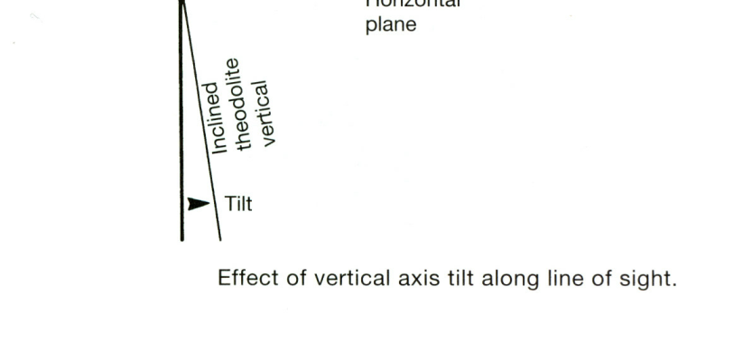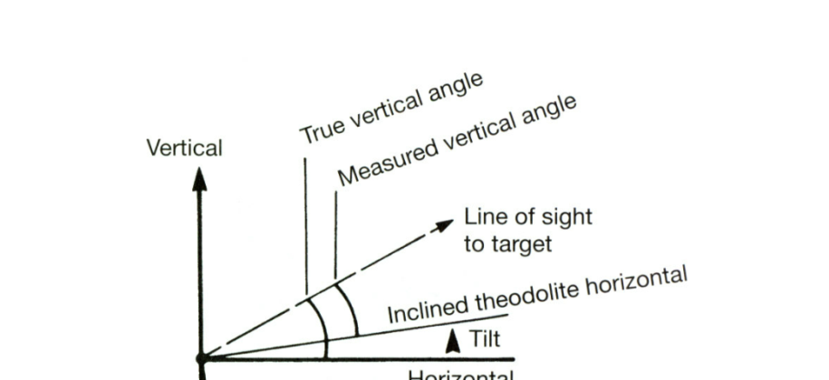

If the instrument is not level, it is not possible to remove any errors caused by this when observing and setting angles on both faces. If the theodolite is levelled electronically, it will usually be fitted with a dual-axis compensator and it can calculate corrections for any errors caused by vertical axis tilt and will apply these to displayed horizontal and vertical angles.

However, the compensator itself may be out of adjustment. To correct for this, an on-board electronic calibration can be carried out in which the compensator index errors are measured and then automatically applied to all readings. It can be shown that the error in horizontal angles caused by the theodolite not being level is proportional to the tangent of the vertical angle of the line of sight.

Consequently, it is important to ensure that the theodolite is carefully levelled for any steep sightings such as those taken to tall buildings and into deep excavations when on site.

**2. Errors in the equipment: Horizontal collimation error**

This error occurs when the line of sight is not perpendicular to the tilting axis - this detected by taking face left and face right horizontal circle readings to the same point – if these do not differ by exactly 180˚, the theodolite has a horizontal collimation error.

The error is removed by taking the average of face left and face right readings to any given point and by taking the mid-point when setting out angles on both faces. It can also be removed in an electronic calibration.

**3. Errors in the equipment: Tilting Axis not horizontal**

If the tilting axis of the theodolite is not perpendicular to the vertical axis, it will not be horizontal when the theodolite has been levelled. Since the telescope rotates about the tilting axis it will not move in a vertical plane which will give rise to errors in measured horizontal angles.

As with the horizontal collimation error, this error is also removed by taking the average of face left and face right readings, by setting out on two faces or by carrying out an electronic calibration on the instrument.

**4. Errors in the equipment: Vertical Collimation error**

When a theodolite is levelled, it is assumed that the automatic vertical circle index sets the vertical circle to read 90˚ when horizontal on face left and 270˚ when horizontal on face right. To detect this error, the same point is sighted on face left and face right and a vertical circle reading taken – when added these should be exactly 360˚ or a vertical collimation error is present in the theodolite.

The vertical collimation error is cancelled by taking the mean of face left and face right readings. To remove this error, an electronic calibration can be carried out.

**5. Errors in the equipment: Plummet error**

The line of collimation of an optical or laser plummet must coincide with the vertical axis of the theodolite. Tests should be carried out on site to check this.

**6. Errors in the equipment: Tripods and Tribach**

The clamping mechanism and circular bubbles of tribrachs should be checked regularly. All of the parts of a tripod should also be inspected regularly to check that they have not become loose.

**7. Field or on site errors: Instrument not levelled properly**

Failure to level a theodolite properly will cause the vertical axis to be tilted

If the instrument has been poorly levelled, errors will occur in measured angles that are not eliminated by observing on face left and face right. Although instruments fitted with dual-axis compensators can correct for the effects of a tilted ver tical axis, it is still good practice to take some care when levelling theodolite that have a compensator. If a theodolite is found to be off level whilst measuring or setting out an angle, it is best to re-level the instrument and repeat the measurements.

**8. Field or on site errors: Mis-centering**

If a theodolite is not centered exactly over a point incorrect horizontal angles will be measured. This error increases as the line of sight gets shorter, consequently, great care must be taken with centering when sighting over the short distances that are often used on site and in engineering surveying.

The same errors can occur if a tripod mounted target is not centered properly and when a detail pole is either mis-centered or is not held vertical.

**9. Field or on site errors: not using theodolite properly**

* Make sure parallax is removed
* Change the focus for each target sighted
* Use the tangent (slow motion) screws to intersect targets
* Don’t lean on the tripod

**10. Field or on site errors: ground and weather conditions**

* Avoid setting the instrument up on soft ground
* When working in hot sunshine shade the instrument
* Do not take measurements when refraction is a problem
* Let the instrument adjust to atmospheric conditions

Observing and setting out angles in windy conditions is not recommended

**COMPASS SURVEY**

**STUDY OF COMPASS USED IN COMPASS SURVEYING**

**Aim:** To study the different types of compass used in compass surveying.

**Instrument:**

* Engineering Compass

**Theory:**

What is compass survey?

Compass survey is a method of surveying by taking bearings and linear distances to produce plan. Bearing is measured using prismatic compass, while the linear distance is measured using measuring tape.

Compass surveying is recommended for use to survey a large area to include:

* The course of a river (or) coast line.
* An area crowded with many details and triangulation is not possible

**Definition of a few compass terms:**

1. MERIDIAN – it is the fixed direction in which the bearings of survey lines are expressed
2. BEARING – it is horizontal angle between the reference meridian and the survey line measured in clockwise or anticlockwise direction
3. TRUE MERIDIAN – The true meridian passing through a point on the earth surface is the line in which a plane passing through and the north and south poles, intersects the surface of the earth.
4. TRUE BEARING – The horizontal angle measured clockwise between the true meridian and the line is called true bearing of the line.
5. MAGNETIC MERIDIAN – the direction indicated by a freely suspended and balanced magnetic needle unaffected by local attractive forces
6. MAGNETIC BEARING – The horizontal angle which a line makes with the magnetic meridian.

**SOURCES OF ERROR IN COMPASS WORK**

* Instrumental errors
* Observational or personal errors
* Errors due to External Influences (natural causes)

**Instrumental Errors:**

They are those which rise due to the faulty adjustments of the instruments. They may be due to the following reasons:

• The needle not being perfectly straight.

• Pivot being bent

• Sluggish needle

• Blunt pivot point

• Improper balancing weight

• Plane of sight not being vertical

• Line of sight not passing through the center of graduated ring

**Observational or Personal Errors:**

They may be due to the following reasons:

•Inaccurate leveling of the compass box.

• Inaccurate centering.

• Inaccurate bisection of signals.

• Carelessness in reading and recording.

**Natural Errors:**

They may be due to following reasons:

• Variation in declination

• Local attraction due to proximity of local attraction forces.

• Magnetic changes in the atmosphere due to clouds and storms.

• Irregular variations due to magnetic storms etc.

**TYPES OF COMPASS:**

There are two types of compass, namely:

1. Prismatic Compass (0 to 360 Degrees)

2. Surveyor’s Compass (0 to 90 Degrees)

The working of a Prismatic compass involves the following three steps: centering, leveling and observation of bearing.

**Fore Bearing and Back Bearing:** The bearing of the line in the direction of progress of the survey is called Fore-Bearing (FB), while the bearing in the opposite direction is called Back Bearing (BB). Therefore BB of a line differs from FB by exactly 180o.

**Designations of bearings**

Bearings are expressed in the following ways;

* **Whole circle bearing:** In this system, the bearing of a line is measured with the magnetic north in clockwise direction. The value of bearing thus varies from 0o to 360o.
* **Quadrant bearing:** In this system, the bearing of a line is measured eastward or westward from north or south whichever is near. The directions can be either clock wise or anti clockwise depending upon the position of the line. It will have value up to 90o.

**DIFFERENCE BETWEEN THE PRISMATIC COMPASS AND THE SURVEYOR'S COMPASS.**

1. Prismatic Compass
   1. The sighting of an object and reading of the bearing are done simultaneously
   2. This can be used without stand
   3. The graduated ring is attached to the magnetic needle
   4. Graduation are marked 0o and 360o in clockwise direction
   5. 0o is marked at south, 180o at north, 90o at west and 270o is marked at east.
   6. It measures or gives the whole circle bearing of a line.
2. Surveyor’s Compass
   1. An object is sighted first and the bearing is then read by going vertically over the middle point
   2. This cannot be used without a stand
   3. The graduated ring and needle are free to move with respect to each other
   4. Graduation are marked 0o to 90o in each quadrant
   5. In this compass, east and west are interchanged
   6. It measures or gives the quadrant bearing of a line

**DESCRIPTION OF THE PARTS OF A COMPASS**

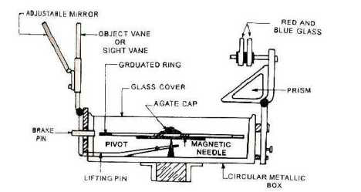

1. Compass Box 2. Magnetic Needle

3. Graduated Ring 4. Pivot

5. Objective Vane 6. Eye Vane

7. Adjustable Mirror 8. Spring Brake

9. Brake Pin 10. Lifting Lever

11. Lifting Pin 12. Prism

13. Focusing Stud 14. Glass Cover

15. Prism Dust Cap 16. Sun Glasses

**COMPASS BOX:**

It is a circular box of diameter 85 to 110 mm having pivot at the center and covered with plain glass at top.

**MAGNETIC NEEDLE:**

It facilitates in taking the bearings of survey lines with reference to the magnetic north.

**GRADUATED RING:**

The bearings are marked inverted on the graduated Rings from 0° to 360° in a clock-wise starting 0° from south.

**PIVOT:**

Magnet is freely held with this.

**OBJECT VANE:**

It consists of prism with a sighting slit at the top. The prism magnifies and erects the inverted graduations.

**BRAKE PIN:**

It is pressed to stop the oscillations of the graduated ring.

**LIFTING PIN:**

On pressing it brings the lifting lever into action.

**COLOUR GLASSES:**

Red and blue glasses are provided with the prism to sight luminous objects

**PRISMATIC COMPASS**

**Aim:**

- To study the prismatic compass and

- To determine,

* Fore and back bearing of line AB, BC, CA.
* The included angles.

**Apparatus:** Tripod, prismatic compass, ranging rods, measuring tapes, wooden pegs, hammer.

**Theory:**

**Fore Bearing:** The bearing of a line measured in the direction of progress of survey is called Fore-Bearing.

**Back Bearing:** The bearing of a line measured in the opposite direction of progress of survey is called Fore-Bearing.

**Parts of a prismatic compass**

**Compass Box:**

1. Circular 8 to 10 cm (80mm to 100mm) metallic

2. At the center of box pivot is provided.

**Magnetic Needle and Graduated Ring:**

1. On pivot the magnetic needle rests

2. Aluminum graduated ring is attached to needle

3. Graduated ring has 0 degree to 360 degrees clockwise

4. i.e. 00 at south, 900 at west, 1800 at north, 2700 at east

5. Least count is 30minutes

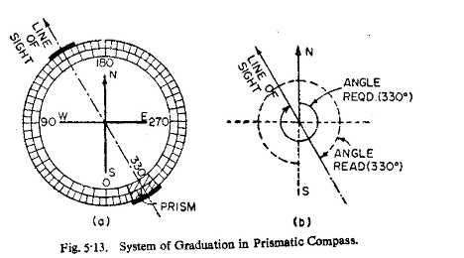

**Sight Vane and Object Vane Of Compass:**

* These are fixed diametrically opposite to the each other.
* Object vane consists of vertical hair attached to the frame
* Sight vane (or eye slit) consists of vertical slit cut into upper assembly of the prism unit. Prism unit is hinged to the box
* Adjustments of Prismatic Compass
* Fixing the compass with tripod stand.
* Centering
* Leveling
* Adjustment of prism
* Observation of bearing
* Bearings are designated by two systems
* Whole Circle Bearing (WCB )
* Quadrantal Bearing or Reduced bearings( QB / RB )
* Whole circle bearing (W.C.B.)
* The bearing of a line measured from the north in clockwise direction.
* The value of WCB may vary from 00 to 3600

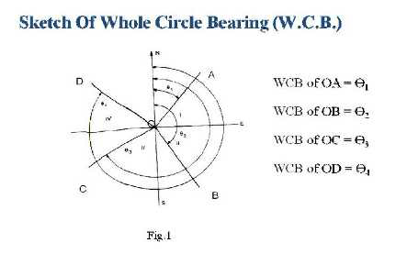

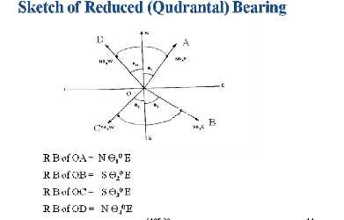

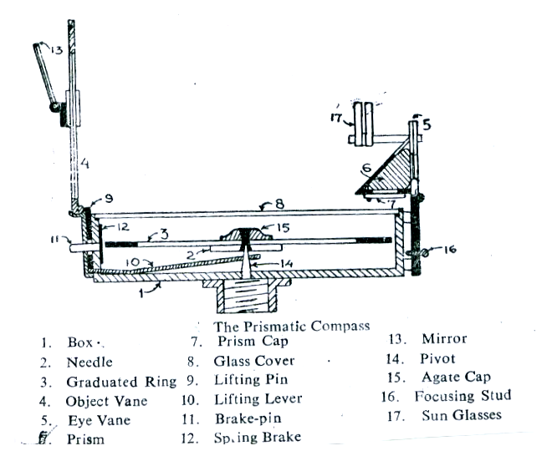

**SETTING OUT STRAIGHT LINES AROUND A BUILDING**

**Aim:**

To measure the distance between two points on a level ground by direct ranging

To set out straight lines around a building

To measure the offset distance from the building

**Apparatus:** ranging poles, chain, arrows, pegs, measuring tape.

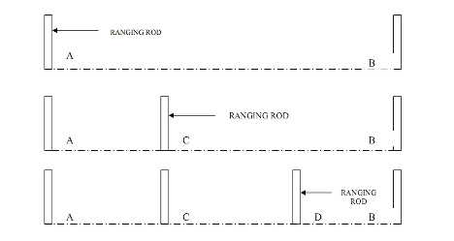

**Procedure:**

* Fix the ranging rods at the two given stations, where pegs are already driven on the ground.
* The follower stands behind station A and directs the leader, with ranging rod to come in line with AB by signals of ranging.
* When the ranging rod comes in the line of AB the follower directs the leader to fix the ranging rod in position.
* Let the intermediate point be C which should be less than 20m / 30 m
* Now the leader takes another ranging rod and stands between A and B about 2/3 distance from A
* The follower directs the leader to come in line of AB by using signals of ranging.
* As and when the point is located in the line of AB the follower instructs to fix the ranging rod in position.
* Let the other intermediate position be D which is less than 20 m / 30 m from B
* Now A, B, C and D are in a straight line. Now the leader and follower measure the distance by measuring along A, C, D, B.

**Results:**

The distance between AB = __________ m.

The distance between AC = __________ m.

The distance between CD = __________ m.

The distance between DB = __________ m.

The offset distance is = __________ m.

From the recorded measurements of the building, calculate area.

**SETTING UP THE COMPASS – OBSERVATION OF BEARINGS**

**Aim:** To perform station adjustments and to observe magnetic bearings using a prismatic compass.

**Apparatus:** Prismatic compass, Tripod and Ranging rods etc.

**Sketch:**

N

A

B

S

c

O

**Procedure:**

The following station adjustments are to be done at each station where the compass is set up.

1. **CENTERING:**

a. Centering is the process of keeping the prismatic compass over the station point.

1. By moving the legs of the tripod suitably, centering will be done.
2. Centering is checked by dropping a stone so that it falls on the top of the peg.

2. **LEVELING:**

a. Leveling is the process of making the compass exactly horizontal.

b. Level the compass by means of a ball and socket arrangements.

c. When the compass is leveled, the aluminum ring swings freely.

3. **FOCUSSING:** To adjust the height of the prism so that the observations can be read clearly.

4. **OBSERVING BEARINGS:**

1. Set up the prismatic compass over station “O” and perform station adjustments.
2. Rotate the compass till the line of sight bisects the object at “A”.
3. Read the graduated ring through prism. The reading directly gives the magnetic bearing of “OA” in whole circle bearing system.
4. Follow the same procedure to observe the magnetic bearings “OB” and “OC”.

**Calculations and Results:**

**Tabular form**

|  |  |  |  |
| --- | --- | --- | --- |
| **S/N.** | **STATION** | **SIGHTED TO** | **W.C.B.** |
|  |  |  |  |
|  |  |  |  |
|  |  |  |  |
|  |  |  |  |